Final projet

BRAILLE PRINTING

MACHINE

MEMBERS:

BENBOUALI MOHAMED AMINE

BERRICHI RIAD

BELHADJ AYMEN

GENERAL INTRODUCTION:

LOUIS BRAILLE, the inventor of the braille language, Louis Braille was a young visually impaired kid who lived between year 1809 and 1852 passing away to tuberculosis, this impeccable young man developed the first ever universal reading and right language for visually impaired people at the age of 15 years old and kept developing it until he published it at 20 years old, he also codified a music braille system. Louis Braille despite his lack of vision went out to become the first visually impaired apprentice teacher at the New School for the Blind in Paris, France. There, he taught algebra and music.

(Source: number 3 appendix 1)

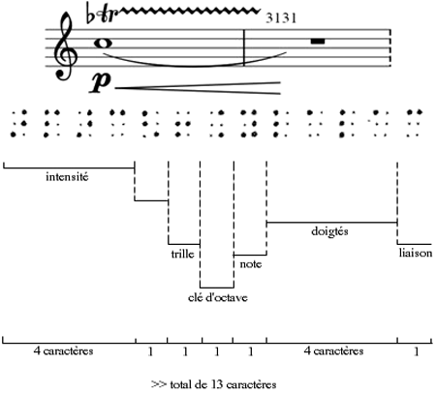

Figure 1: One of Braille’s musical systems (source: number 2 appendix 1)

Braille is a reading and writing language that visually impaired people can use to receive visual information by the form of touch, passing your fingertips over precisely threaded dots on a book allows you to read without the need of vision. In early days braille was printed on books using a braille writer (similar to a typewriter) or by using a pointed stylus to punch dots through paper using an instrument called a Braille slate.

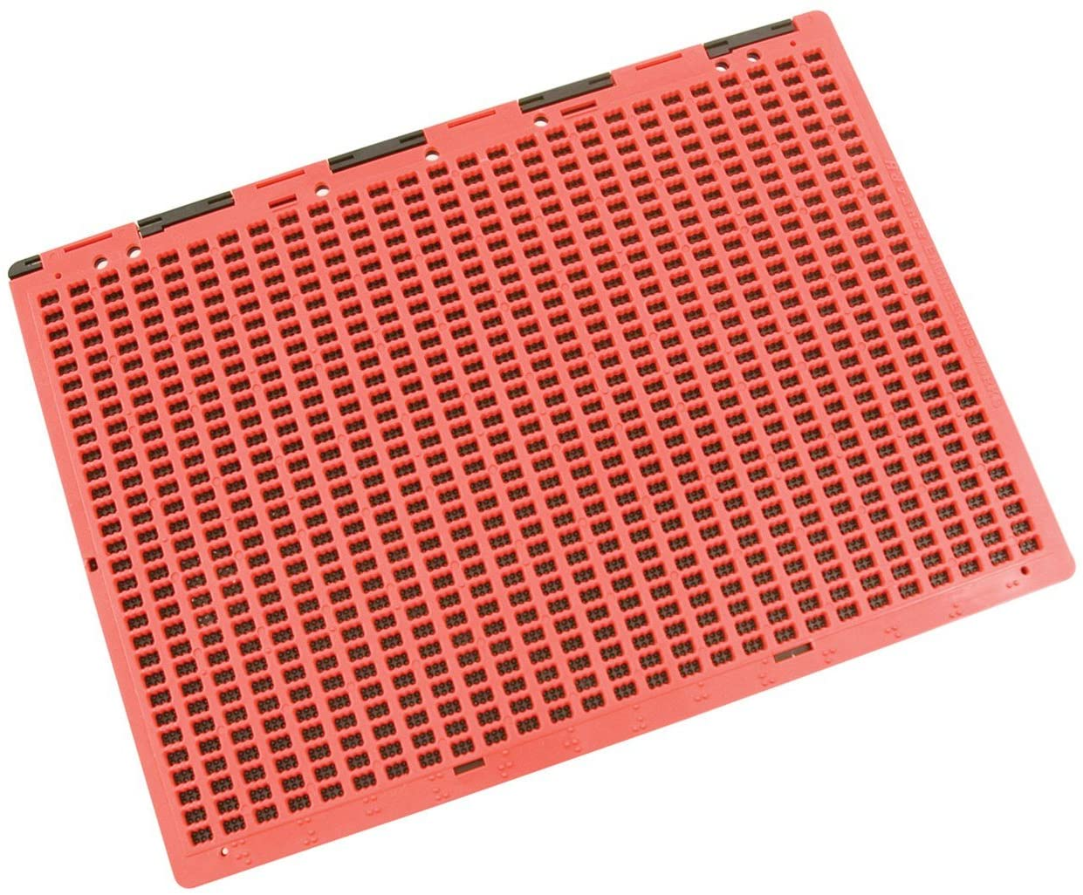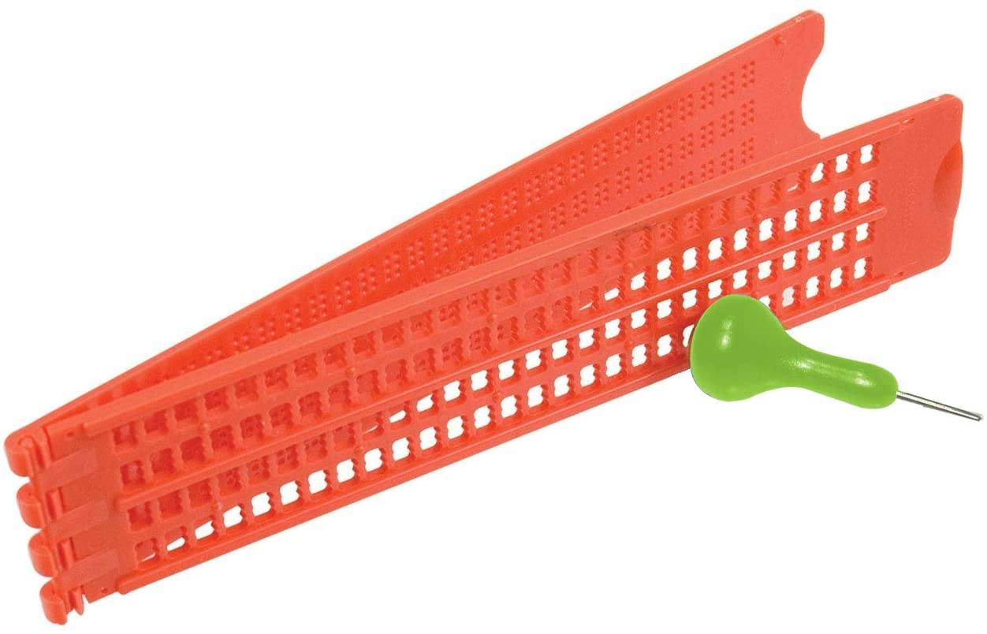

Figure 2: Braille slates (source: number 1 in appendix 1)

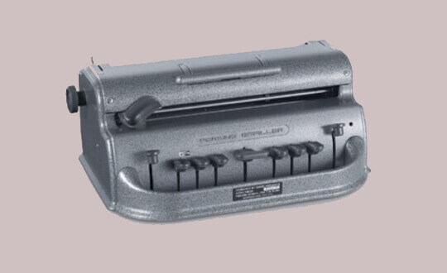

Figure 3: Braille writer (Source: number 4 appendix 1)

CHAPTER 1:

GENERALITIES & DEFINITIONS: (in appendix 2)

THE PROBLEM:

We noticed (with the help of our supervisor) that braille requires people who are not visually impaired to be printed by Braille slates (Figure 2) or braille writers **(Figure 3) and this is a major problem as this means** visually impaired **people must be dependent on non-** visually impaired **people to product books, printings, and overall messages.**

OUR PURPOSE:

The purpose of our work is to offer a new way of printing braille, a way that doesn’t require people who could see to setup for a visually impaired person and to offer visually impaired people a way to become independent in printing their own braille at the click of a button.

HOW TO PROCEED TO SOLVE THE PROBLEM:

So to solve this problem of visually impaired people having to depend on non-visually impaired people we decided it would be a suitable idea to offer a type of printing machine, NOT a braille writer like in figure 3 which still requires a person to type on in order to produce braille-written paper, but a sort of automatic braille writer where the machine itself types on the paper.

You may ask how will this machine print actual braille on a paper which involves poking it, how will it know which content you want to be printed? How can a visually impaired person operate this machine and is it easy? All these questions we asked ourselves and came to software/hardware solutions for each one, starting from the next chapter.

Phones and audio playings are great ways for visually impaired people to receive information but there are two issues with these methods:

1. Audio playings are hard to come by for everything the visually impaired person likes, most books are now available in audio format on sites such as Audible by Amazon (is not free) but when it comes to any pdf found online you will not find the audio version of every single one, such as research papers.
2. Since they can’t see, putting on headphones at all times makes them vulnerable as they relly on their hearing sense for everything and it has to be interchangeably used for either listening to content or listening to the real world, an example of that is the true story that happened with Byron David Smith who is a visually impaired man who lived alone and was being robbed by 3 people, he rellied on his hearing sense to find and shoot the robbers, this story was later featured in the movie “Don’t Breathe”.



Figure 4: A picture from the movie “Don’t Breathe” of the actor who casted “Byron David Smith” from the real story (Source: number 5 appendix 1)

CHAPTER 2:

OUR SOLUTION:

What is the machine’s main usage case? Everything visually related, we want this machine to allow visually impaired people to print out pdfs not into regular text on a paper but into braille text printed paper, this machine needs to be simple in use, the person could tell his phone via vocal commands to send the pdf into the machine and it would start printing it on the spot, friends of this person could send pdf file from across the world into the machine and it would print them for the visually impaired person directly allowing this person to get more involved in the world than ever before.

During the rise of 3D printers we engineers had to jump in and learn this technology as it is directly related to our domains, and on that note we will be using a lot of 3D printing technology is our solution, 3D printers are known to print absolutely anything you design on 3D design programs such as CAD and Blender and so that technology is exactly what we need to make the machine, we will be using 3D printer specific hardware parts and software technologies and methods to produce our result, of cours it vastly varies from a 3D printer since we will be threading paper instead of building 3D objects but the basics are there, such as moving the drawing head according to coordinates given by the computer.

This machine will require multiple things to come together to work which is what we love, we bring our own software, our own hardware and 3D printing technology together to build this machine, its skeleton will be 3D printed by the help of our school’s scientific club Wameedh, we obtain the machinery from electronics stores and we program our own software to interact with the machine.

NOTE ABOUT SOFTWARE & HARDWARE:

Since our machine involves both software and hardware coming together to achieve this result, we must have a section where both are developed hand in hand but we will first give both separate sections where we explains both the hardware parts and software code that don’t involve each other, after that we will have a software & hardware part where both are being zipped together.

HARDWARE:

A printing machine that could draw and poke a paper of size A4 requires a very strong and consistent structure along with motors, timing belts, linear shafts and specific structural parts or else it will not move precisely.

1. Motors:

For this structure we have to use stepper motors, a strong model of stepper motors is the Nema17 motor.

Why do we use stepper motors?

A stepper motor as opposed to regular DC motors, can spin with what we call steps, if say we were to use a DC motor to move the head to the left we would have to power it for a period of time and stop hoping it will stop at the location we wanted which is super imprecise, but if we were to use a stepper motor we can tell it to spin exactly 1 degree and it will do that every time and precisely.

Why Nema17?

Nema 17 stepper motors are well known to be used in 3D printers, they are strong, precise and cheap stepper motors for this kind of application.

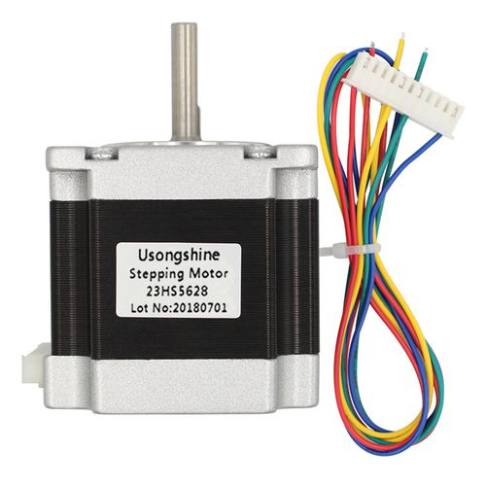

Figure 5: a Nema 16 stepper motor (Source: number 6 appendix 1)

To allow the poking head to move up and down we need a different type of motors called a servo motor, this motor will be directly above the paper operating our threader operation by commands from the computer in the form of two angles, an up angle and a down angle that can be varied until we achieve the amount of threading we need for a usable brailler reading paper. (figure 6)

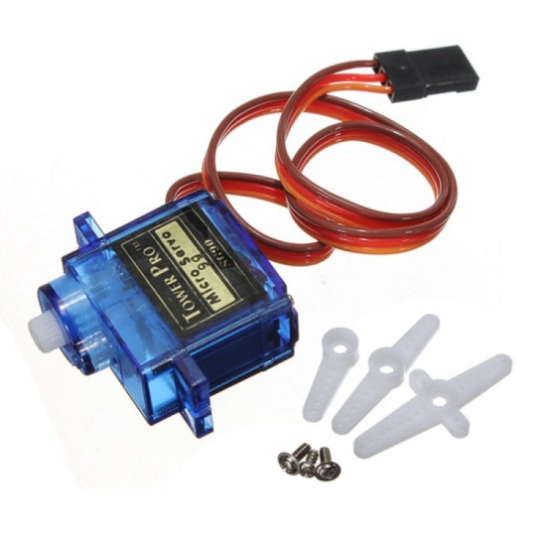

figure 6: SG90 micro small 9g Sevo Motor 1.5KG (Source: number 7 appendix 1)

1. Timing Belts:

For our motors to move a structure left and right by just spinning, we will need timing belts and for that we’ll need a 2 meter long timing belt with relatively tiny teeth along with their matching pulleys.

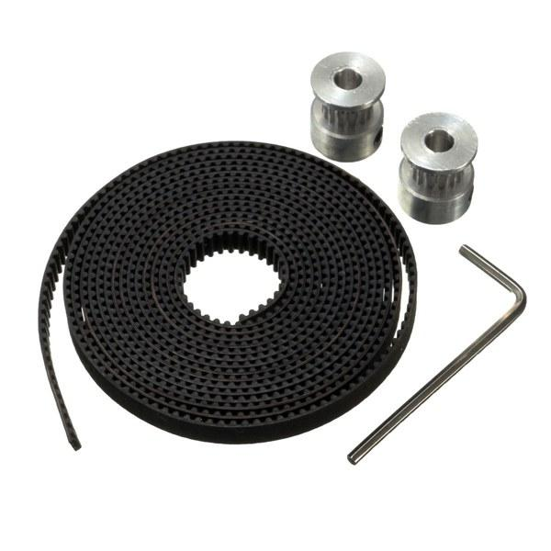

figure 7: a 2 meter long timing belt with its 16 teeth spinning heads (Source 9 appendix 1)

1. Linear Shafts:

The main element that will hold the structure above the paper is called a linear shaft, it’s basically just iron bars with smooth surfaces, they are also the main element in 3D printers, our linear shafts are 8mm thick and 40cm long.

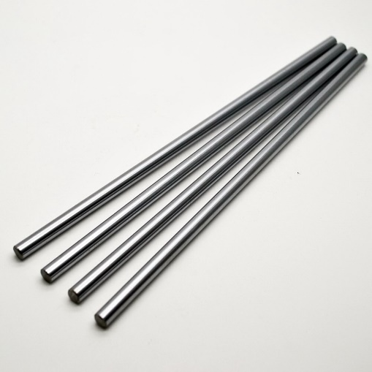

figure 8: linear shafts of length 400mm and diameter 8mm (Source: number 8 appendix 1)

1. Structural parts:

We want a structure similator to this one down below but on a larger scale, the benefits of this structure is that both motors can be situated on one axis only but still be able to steer the head anywhere on x and y axies (more in depth leter on).

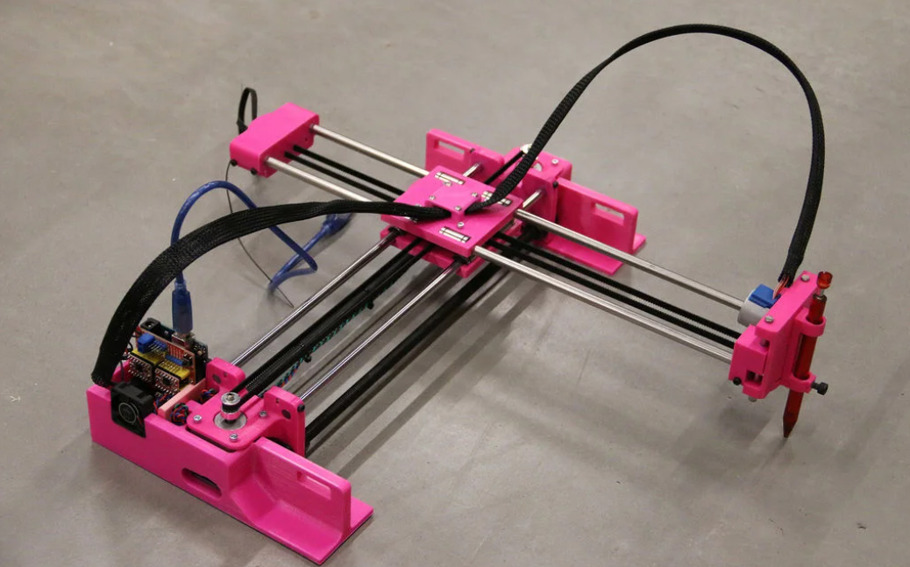

Figure 9: an exmple of a regular drawing machine design that draws with a pen (Source 10 appendix 1)

To hold all of these elements in place we need specifically cut pieces of structure, In this case we will be 3D printing these pieces, below are all of the pieces we designed in the 3D modeling program called Blender.

Side panel (each motor will have this platform) Center panel (takes care of head directions)

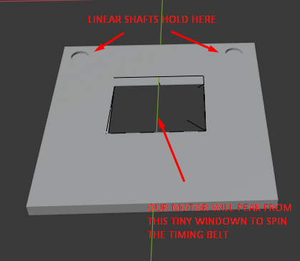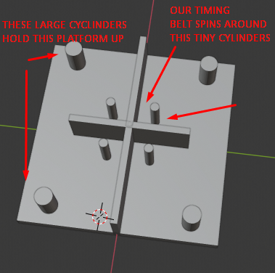

Drawing mechanism (along with a spring) Spinning bolts (allow timing belt to spin interruptionless)

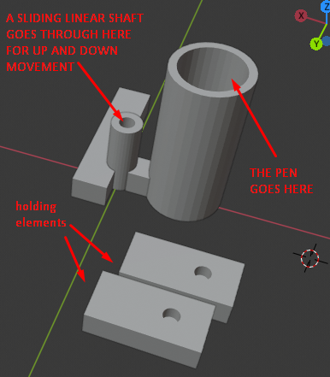 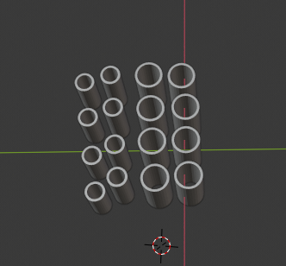

CIRCUITRY:

The circuit that brings all of this together is very simple and logically ties all of the hardware together. (source for circuit below is number 11 from appendix 1)

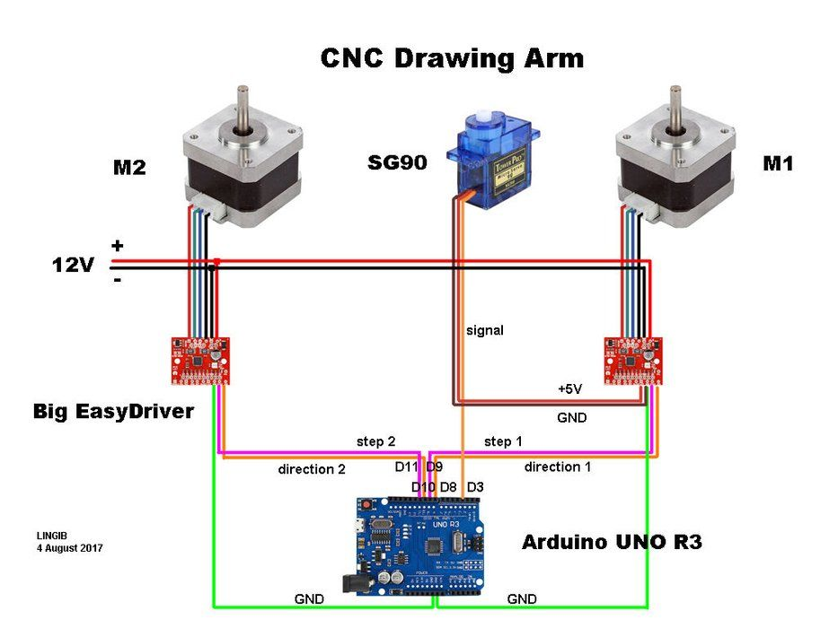

After acquiring all of the materials including an arduino board we were able to wire all of the materials together to have the exact circuit, but without the 3D models shown previously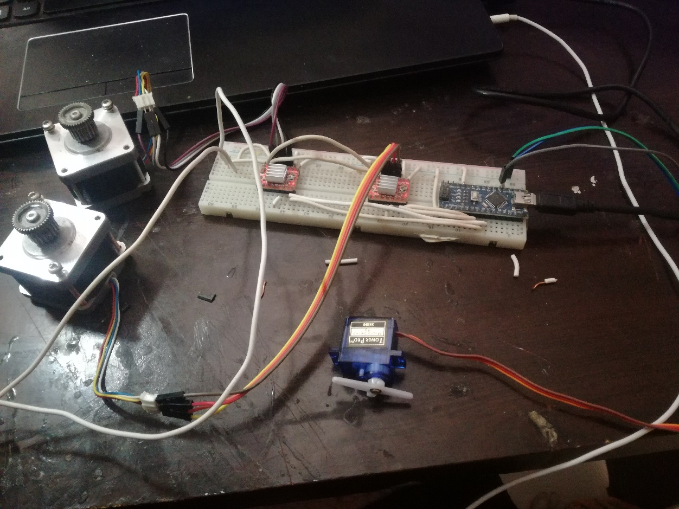

After a few test runs we decided the 9g SG servo motor is too tiny and weak for poking paper so we had to replace it with another nema16 stepper motor just like the the x-y axis motors along with its driver, the circuit came out to the following:

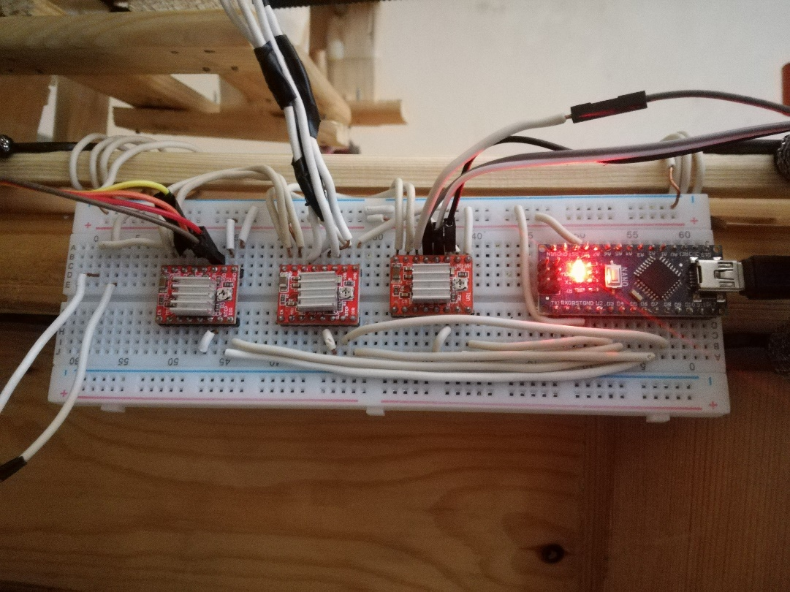

After that we used the timing belt along with the stepper motor to make the z axis mechanism, after a few poking tests with all types of paper we concluded the best poking element was a syringe, it was possible to attach to our machine and was thin enough to poke paper consistently and every single time.

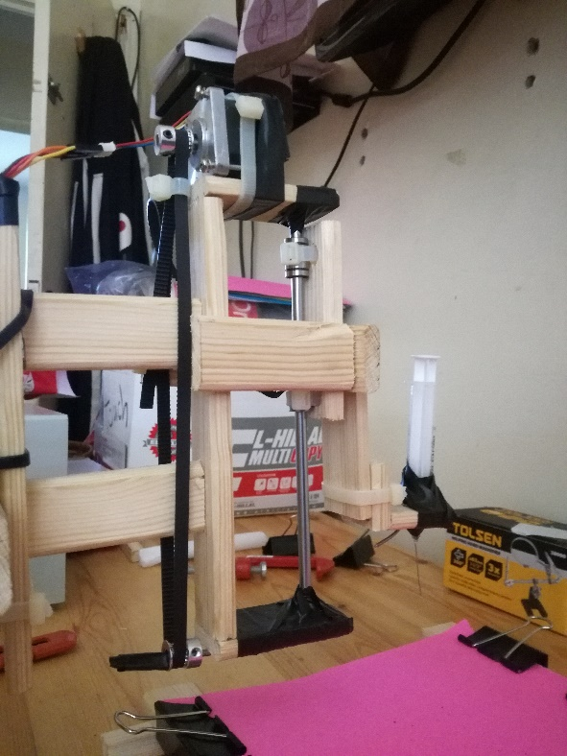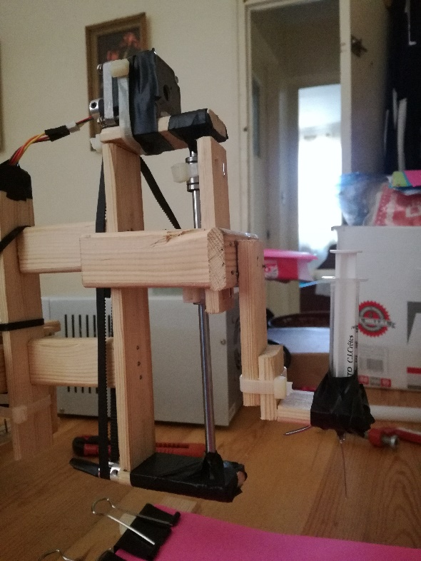

Due to the inability to obtain 3D printed pieces we resorted to building it fully in wood by cutting it and nailing it together, this is still a remarkable prototype with what we are able to obtain, so after a long time of sawing and nailing we got the build!

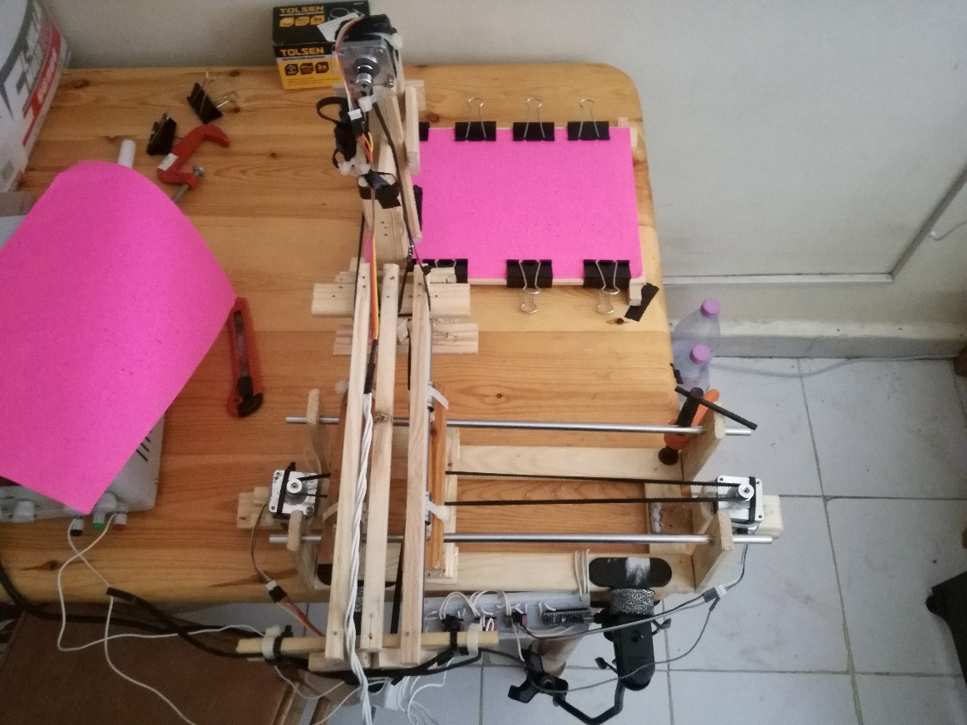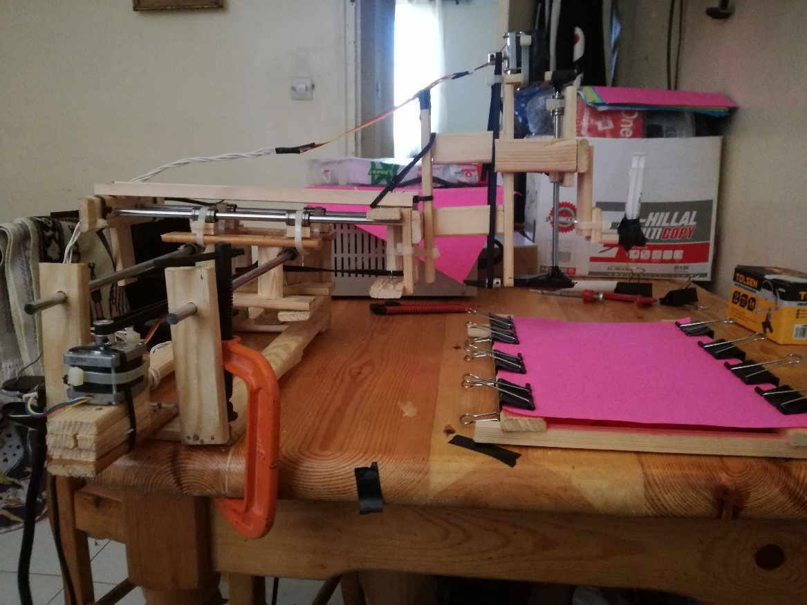

The way our machine moves left, right, back and forth is a result of the spinning combinations of the motors:

1. Both rotate clockwise: the machine goes left.
2. Both rotate anti-clockwise: the machine goes right.
3. Motors rotate in opposite directions: the machine goes back/forth depending on direction.

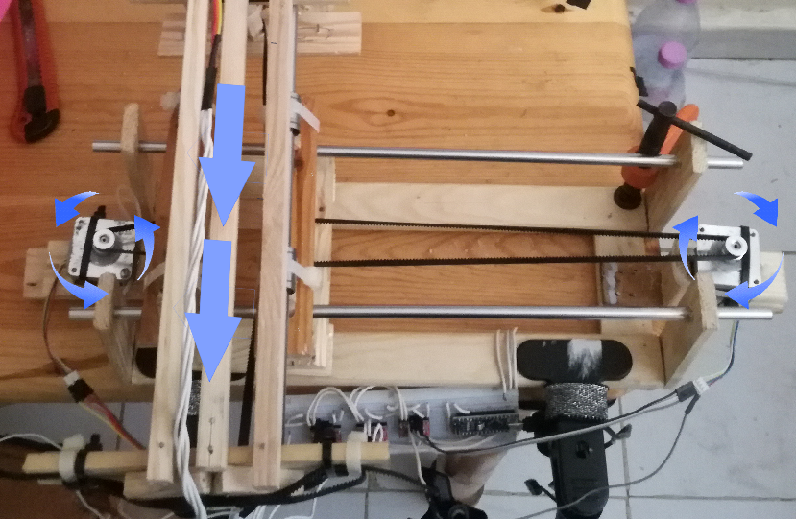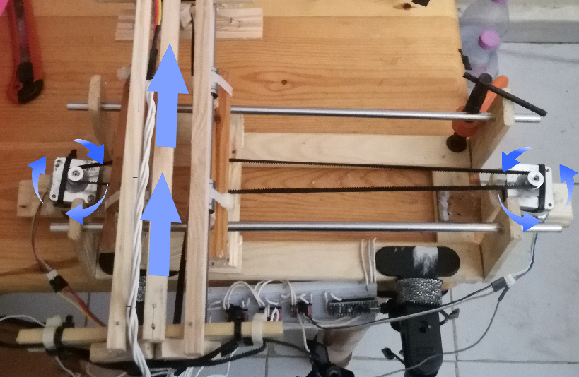

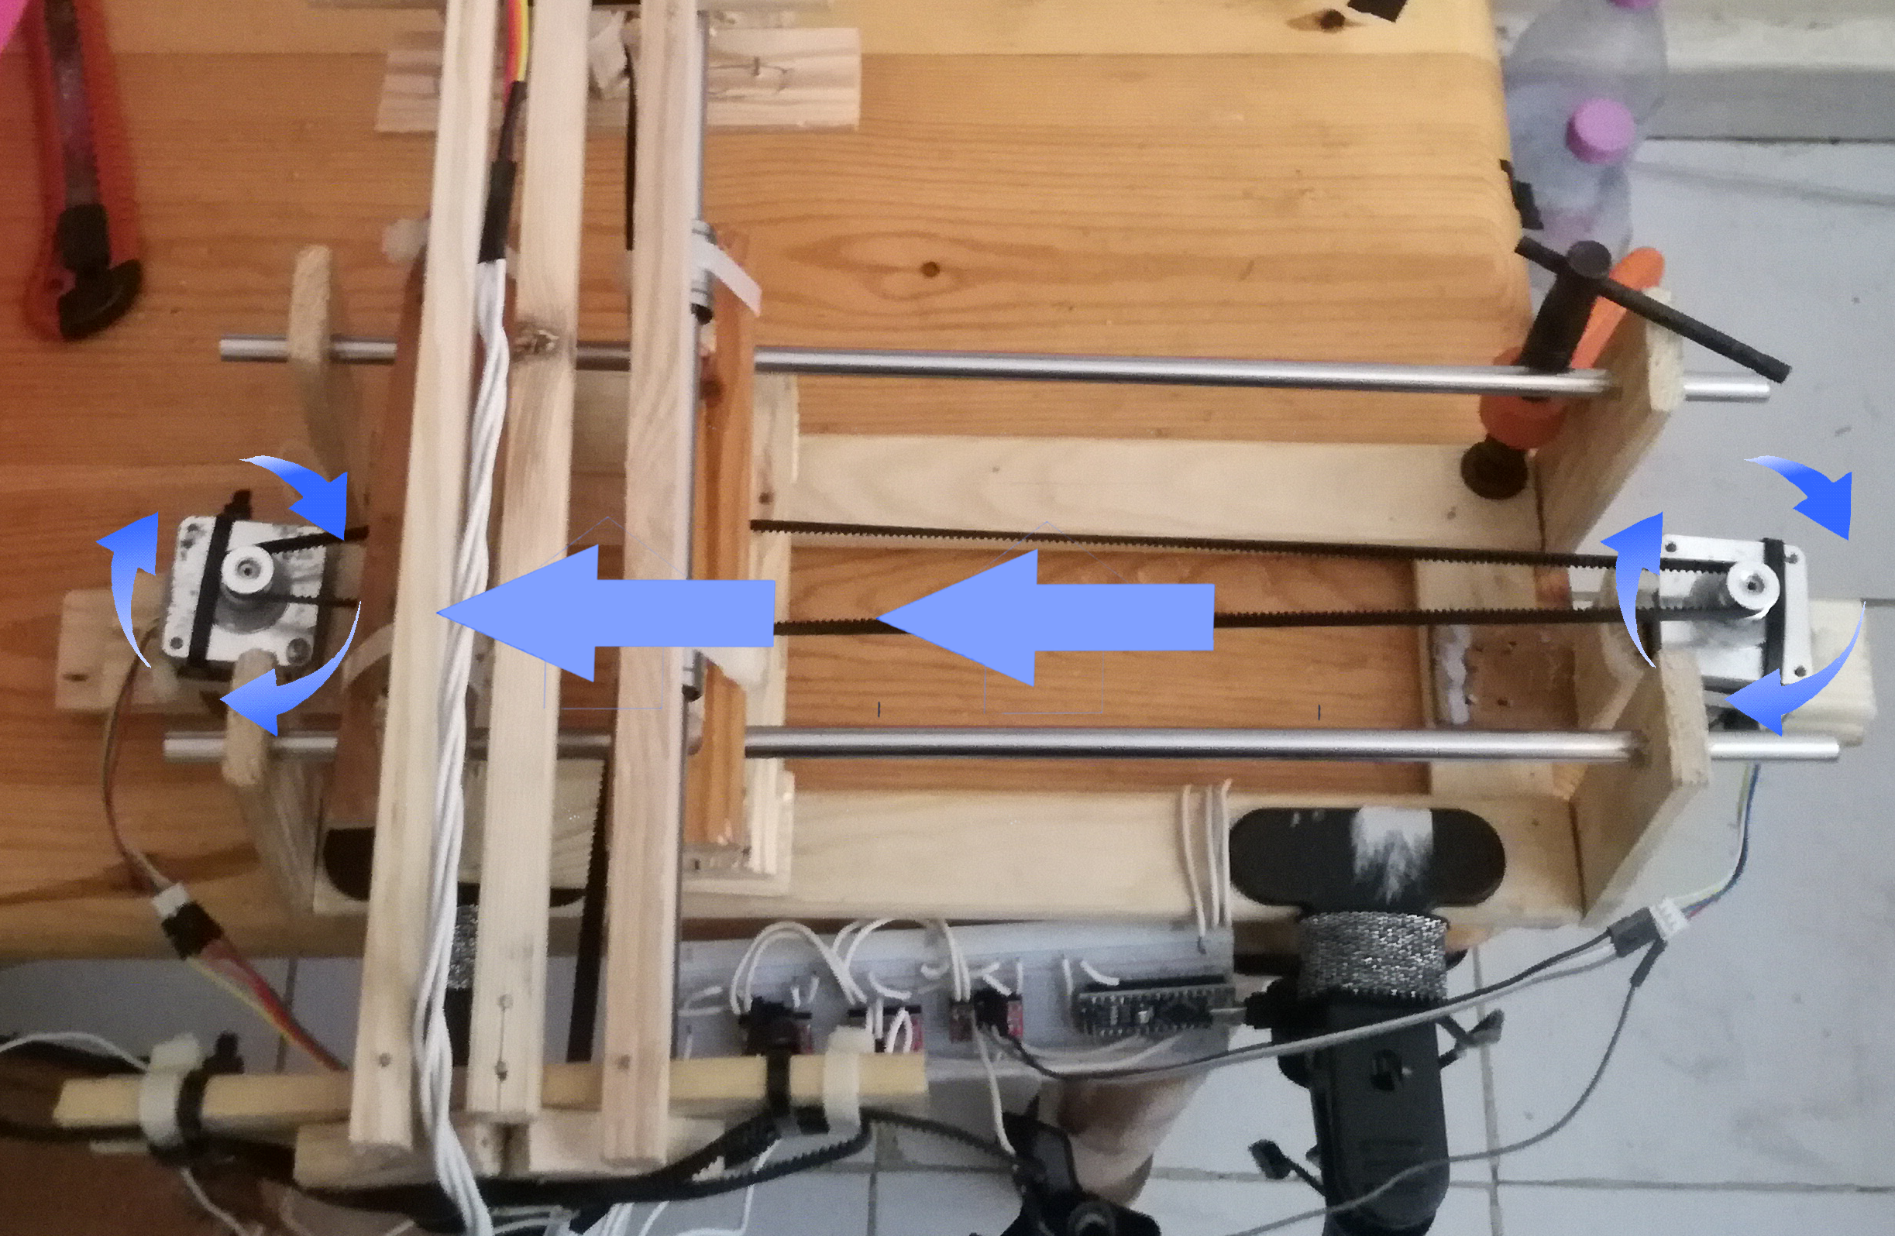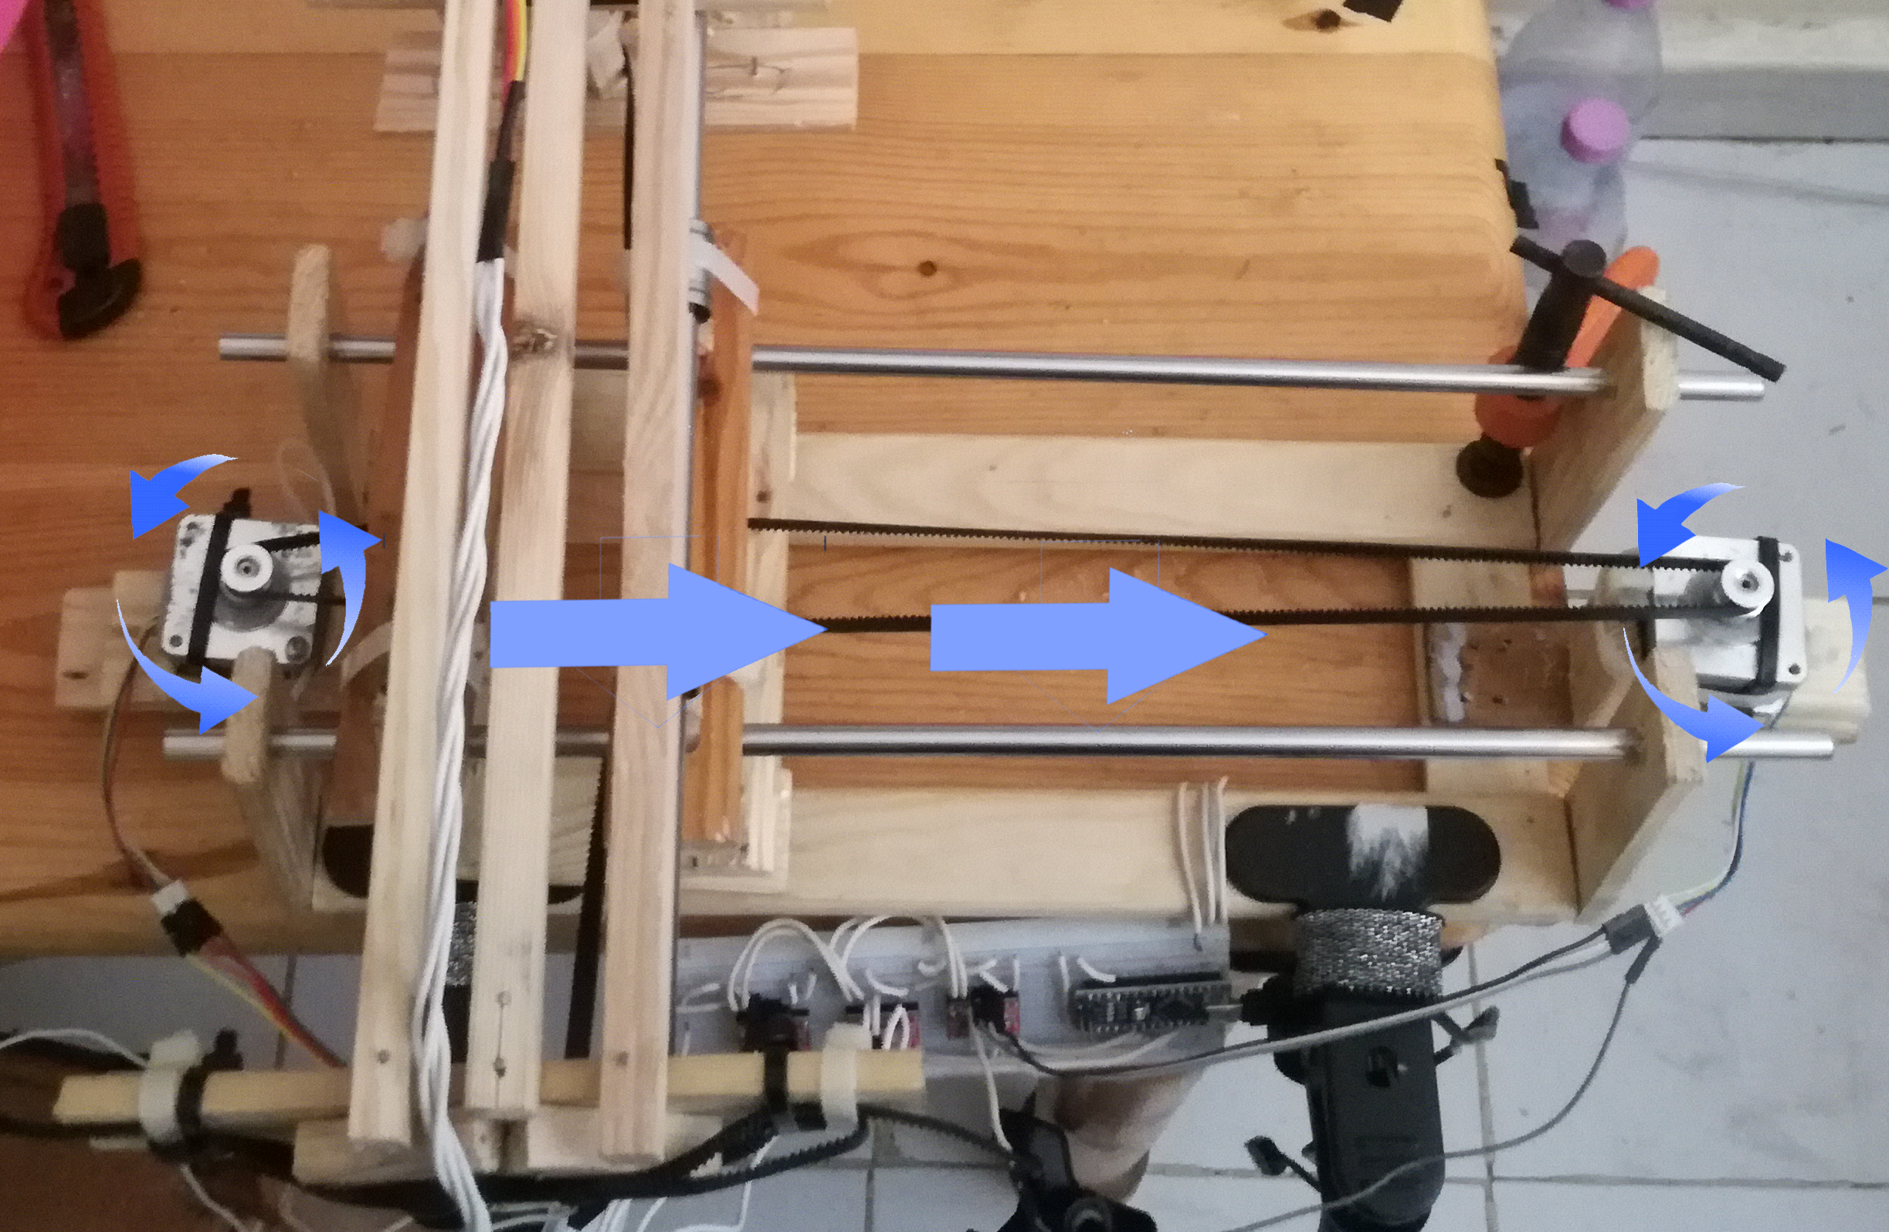

We also have made a wooden frame that can hold a paper in an elevated manner which allows the syringe we attached to go through and not break on the table

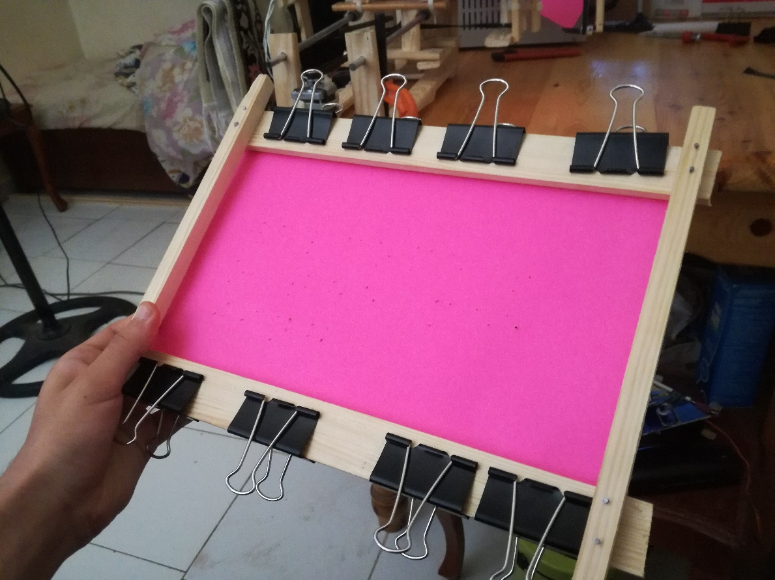

SOFTWARE:

There is no publicly available communication protocol that converts regular text into machine coordinates for Braille printing so we have to write our own.

Text To Braille Language Conversion

We’ll be writing this code on a program called Processing 3, it was originally made to code games but it’s also easy in dealing with machines as it allows us to treat real life machines as games which allows for many industial innovations.

We coded a basic converter for starters to get ahold of braille and how to use it, a good thing about braille is that both letters and numbers have the same braille characters! So A has the same braille as number 1, and letter B has the same braille as number 2 and so on! How we distinguish between them is the letter that comes before which is called an indicator, it lets the reader decide if the next characters are numbers or letters.

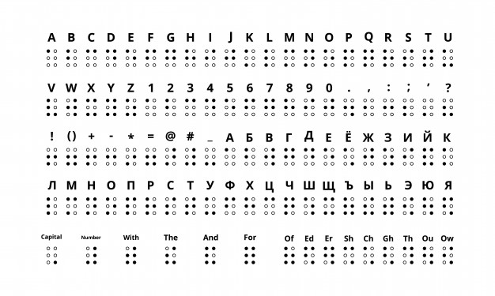

Braille table: Source 12 from appendix 1

For starters, we need 6 dots for every characters in our braille table, but each letter fills specific dots of the 6 available slots, we can use a simple switch case statement to decide which letter we have, for example the letter A and the number 1 are designated by one dot on the top left, the letter B and number 2 are designated by two dots.

(in the code below, we are taking the X and Y coordinates of each dot and adding them to our printing machine’s list of dots that it needs to poke)

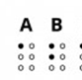

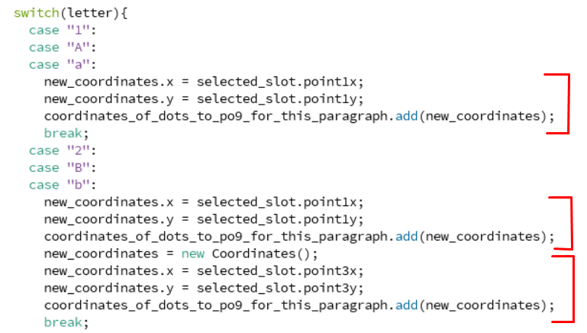

One of the most important features we added was the size of the braille language on the real paper and it can be done with a simple function

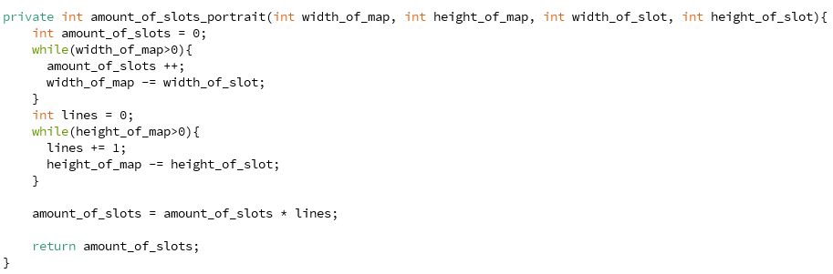

You could give this function the total width and height of the entire paper, and the width and height of each letter and it would count how many letters it could fit in it and returns amount_of_slots, this variable is essential in the printing process as it allows the code to quickly place any sentence into the required slots and instantly send it to the machine.

How this function works is basically looping over the available resolution of the map and count how many times we can fit our designated width_of_slot and height_of_slot.

Now that we got the amounts of slots available, we need to know the exact coordinates of all of those slots and this next function does just that, it takes in the spacing between each slot that is given by the user and the given height & width to calculate the exact coordinates of each dot it needs to poke, this function is what ensures each dot is properly placed relative to the others and letters are consistently spaced away from each other.

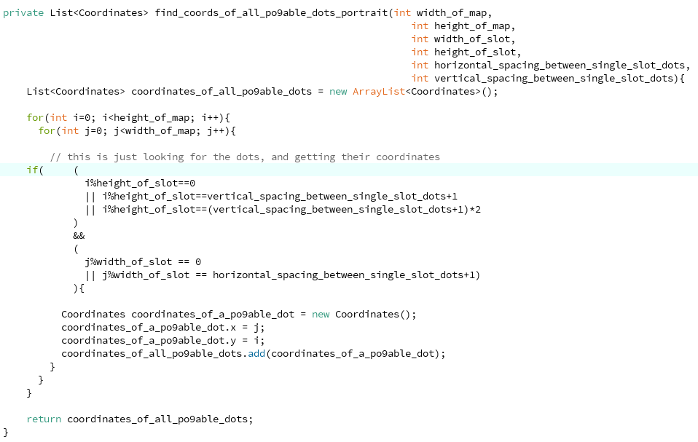

Of cours, we are storing all of these coordinates and so we need a Slot architecture and it contains the x and y for each of its 6 slots.

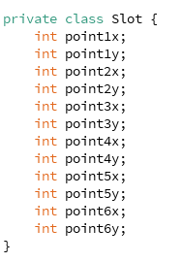

Now everything is organized and we can pass the sentences to our code and it would return a bunch of coordinates that our machine could use, we can plot that on the computer as an example for now:

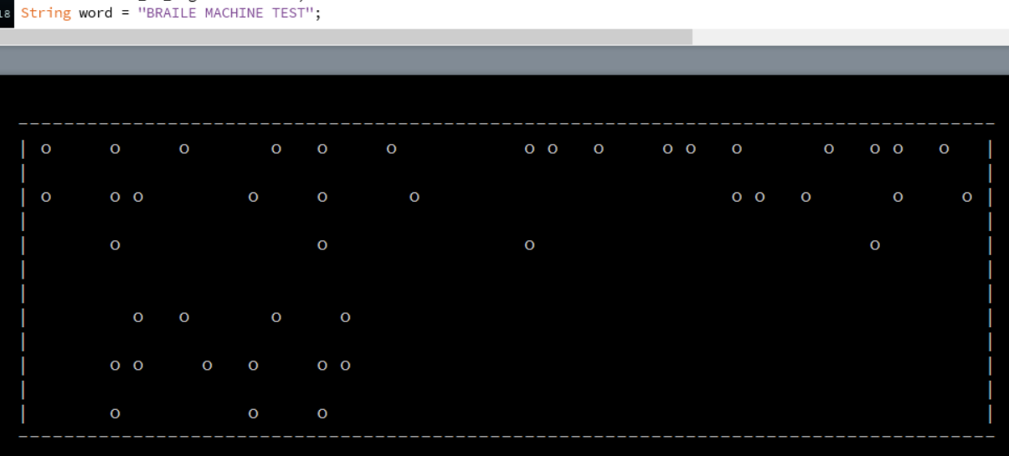

We’ve made it super easy to use the function, the user inputs a sentence and it would return a set of coordinates.



In this converter function we use all of the functions above to determine the necessary information to be able to convert words in three preparation steps

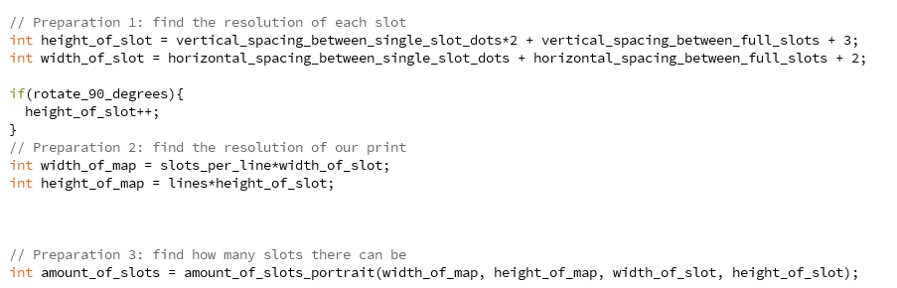

The user can also choose the rotation of the text allowing for horizontal and vertical braille prints on paper.

If the user had chosen vertical prints all we need to do is to switch between our x and y coordinates for each dot and that’s it!

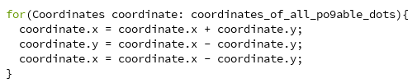

The function above seems unnecessary but it is a cpu friendly way of exchanging values between two variables, we first add the two values and store them in the first variable and then we substract the results and store them in the second variable which eliminates one of the values and then we just substract that value from the total and get the second value, essentially this for loop above is just exchanging values between both variables x and y.

Also we needed a Coordinates architecture, the Coordinates architecture contains two integers x and y.

Now we use a simple print function to decorate the example on a console and we named all of that the print_map_portait, a similar function works for landscape aswell.

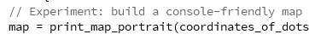

This gets us this test print below!

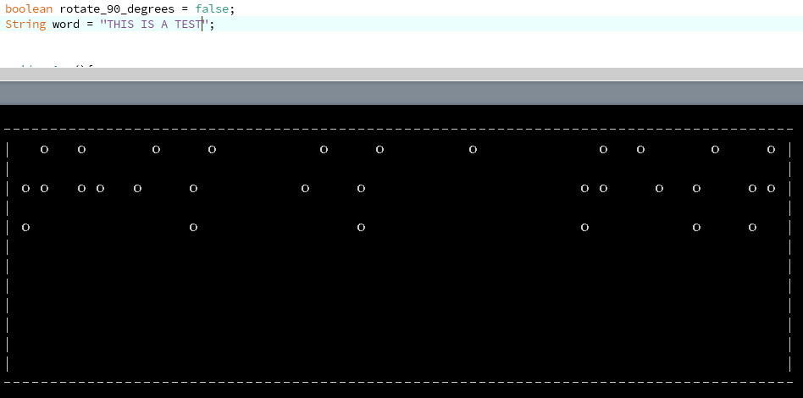

As you could see above the console rotate_90_degrees Is set to false indicating this is a landscape regular print, and the sentence printed is THIS IS A TEST, if you compare this to the string you could notice it is missing the letter indicating symbols that are put between letters and numbers to distinguish between them so let’s add them!

We can easily name them for example the symbol } is for the Numeric Indicator, and / for the Capitalized Letter Indicator and have them be added to this example “{/This is test number }1” of cours the braille reader won’t be reading these brackets in his paper, our code will convert these brackets into the desired indicators from the table above, now all we need to do is write a function that adds these indicators into our sentence.

We will create the add_indicators() function will add these indicators according to our sentence’s capitalization and numbers.

And it simply works by looping over the entire sentence and checking if we have switched from letters to numbers and vice versa, it also checks for capitalization, we repeat,these brackets are not going to be read by anyone but our machine in order to convert them into the appropriate indicators in braille language to be read by visually impaired people.

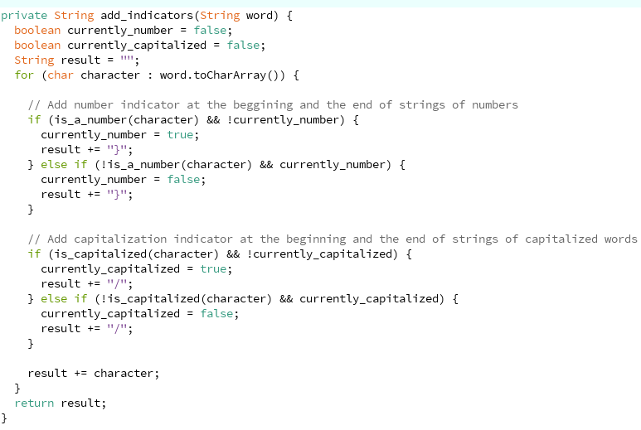

Last but not least we add the symbols into our switch case to have them converted into their designated symbols:

This is essentially just adding the x and y axis of the dots in this table

Number Indicator: checks the dots number 2, 4, 5 and 6.

Capitalization Indicator: only checks the dot number 6.

And now every sentence includes all the required indicators!

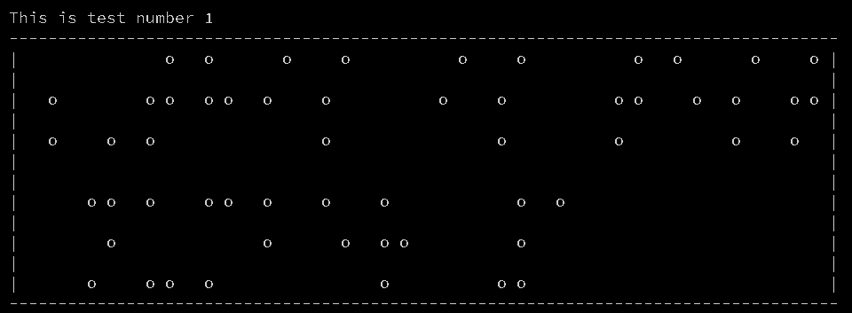

And that’s what the code below exactly does.

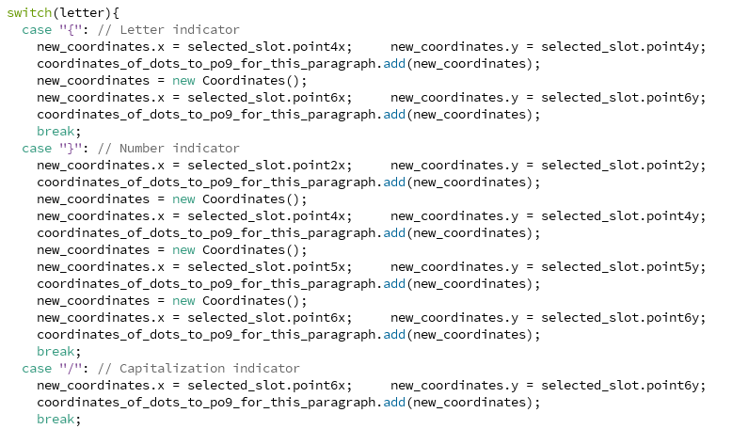

Communication With Machine:

1. The sending side: Processing 3

All we need to do is to loop over our coordinates received from the converter and send them through Serial to our Arduino

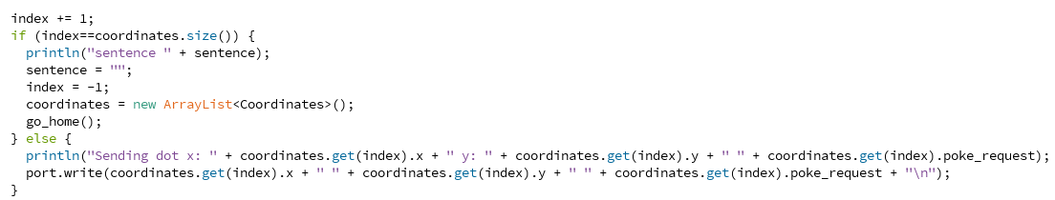

We also expect a response with the text “Done” after the machine has poked the previous dot so we don’t overlap requests.



We built a simple GUI that lets the user type a sentence and send it, this gui is thankfully very easy to make as processing 3 allows us to add lines with 1 line of code.

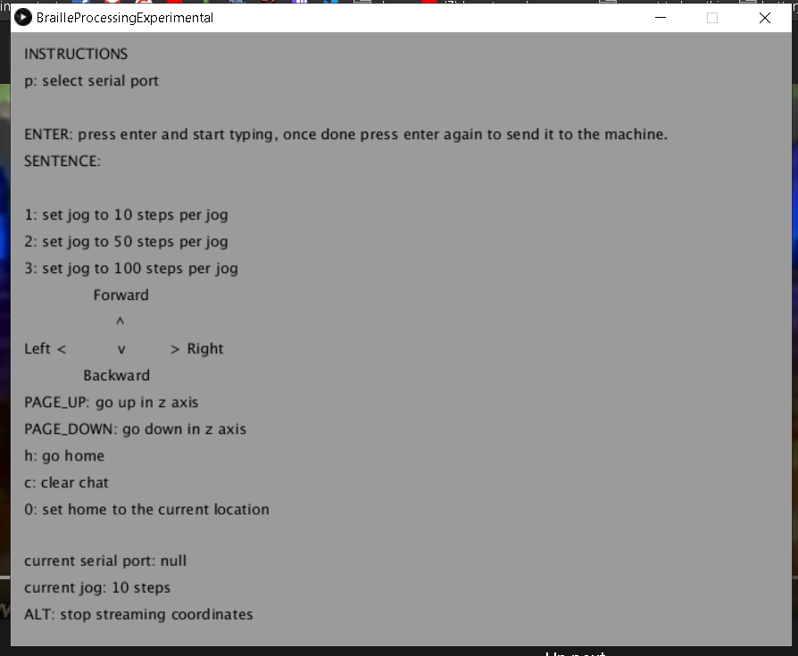 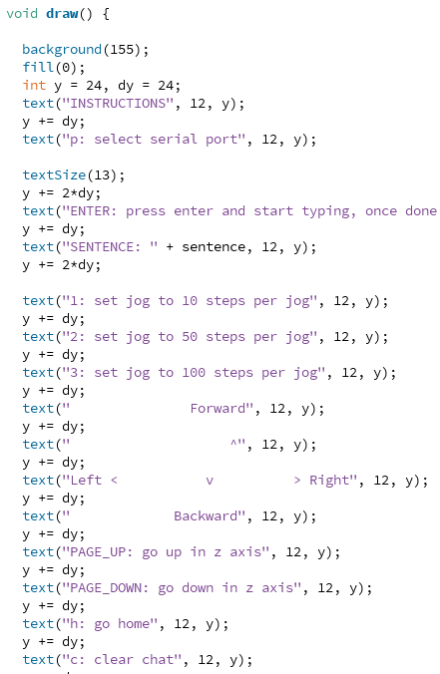

1. The receiving side: Arduino IDE

We will be **using** arduino IDE to program our microcontroller to receive a single type of instruction which consists of a string of three numbers spaced between:

X-coordinate Y-coordinate Poke-request

The coordinates our Text To Braille Converter are going to be sent in a simple string one by one to our machine, the string will contain x and y coordinates as well as a poke-request this poke request will either be a 0 or a 1, it is a 1 if we want our machine to poke the paper at the coordinates provided and 0 means it will not poke the paper and will just go to the x and y coordinates, this is needed to send the machine back to 0 0 after finishing the printing so it is ready for future prints.

Now that we have built the circuit, we are going to control it using Arduino IDE, this code is written in a modified version of the C language made for Arduino and it will help us control our motors in order to steer a proper braille machine.



If we determine the stepper motor’s STEPS variable to be 180, it will step 1 degree each time, but a universally used value is 200 for more accuracy yet less jittering for nema 16/17 stepper motors.



Now it is as easy as one line of code to step each of our stepper motors in any direction by simply entereing positive and negative values into the step() function for both stepper and stepper2.

Now, we receive the string and order the motors to move in the following way:

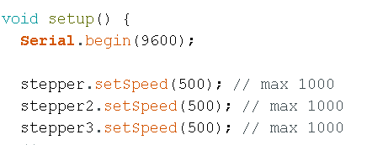

We set the speeds at 50% as they were enough to steer while not pulling as much current, we also initialized the Serial to start listening for coordinates!

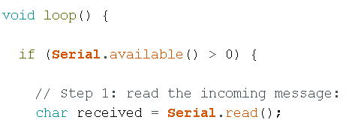

Void loop is an internal function from Arduino that keeps running again and again as long as the arduino is on, we keep checking for messages and if they arrive we read them to add them to our full string.

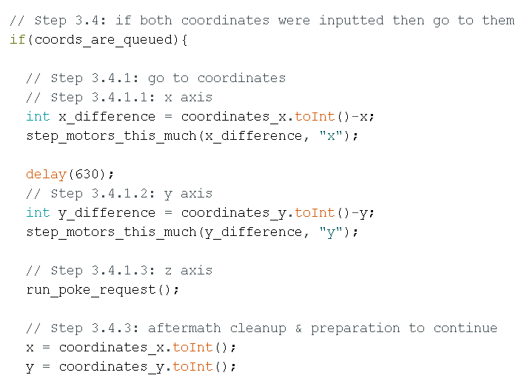

We calculate the difference between the current position of the machine and the received coordinates and we start stepping it towards it, we also run poke_request which uses step() if poke_request = 1.

After that we send a message “Done” to confirm the machine has indeed poked the paper.



And that is it, we press upload and our code gets uploaded on the arduino board!

EXPERIMENTATION & RESULT:

In this section we will be experimenting with the machine and testing its running conditions.

* After switching the power supply on, we can remark that the three motors are pulling 1.21 amps from our DC power supply that we set at 11.9 volts.

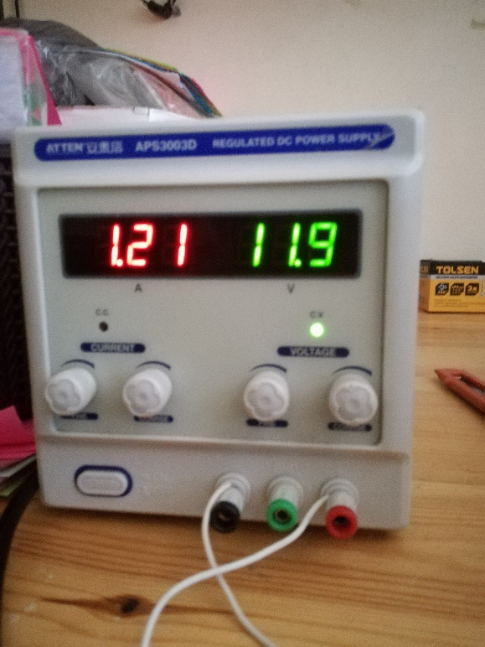

* We run our Processing 3 code and the GUI shows up with the Arduino on COM6 (a USB port)

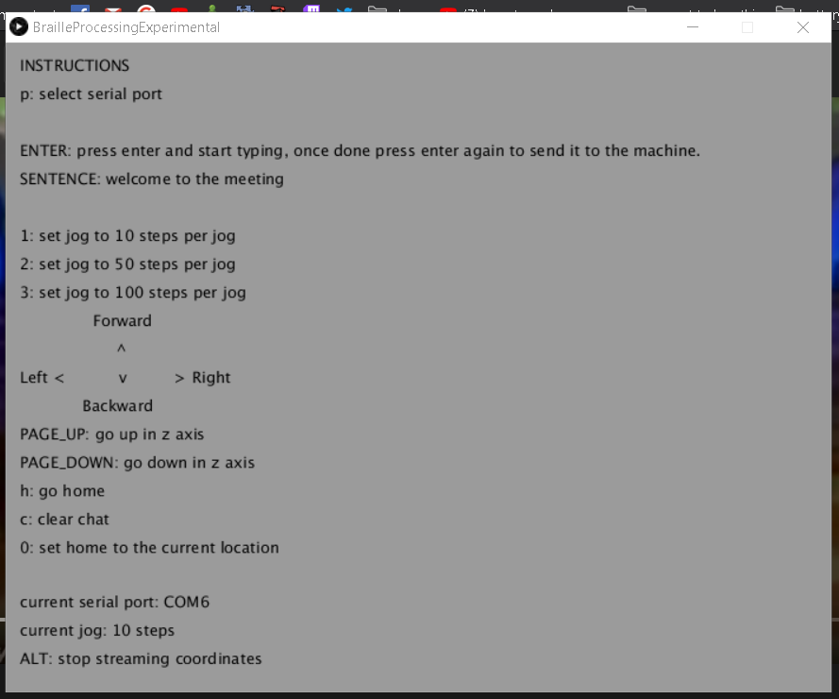

We wrote the sentence “welcome to the meeting” as a test run for our machine, this sentence was suggested by our promoting teacher during a zoom conference call to test the machine.

* We press enter and the machine starts moving after having converted the sentence into coordinates and started the organized stream of coordinates.

We noticed the stepper motors being loud due to vibrations, that thankfully can be fixed by adding capacitors in parallel with the terminals of each coil of our stepper motors which lessens jittering and vibrations.

* Our machine was travelling towards the coordinates and pulling down the syringe towards the paper and effectively poking through it leaving consistent and strong dots that can be felt with the human hand very comfortably, thankfully due to our mirrored map in the converter code, our machine was printing in a mirrored way which allows the reader to read from the other side of the paper which has holes poking out of the paper instead of into the paper which made it way easier to read.
* After our machine has finished printing and went back to 0 0 we unmounted the paper from the simple wooden holder we made for it, the first thing we see is a very clearly aligned set of dots for our sentence.

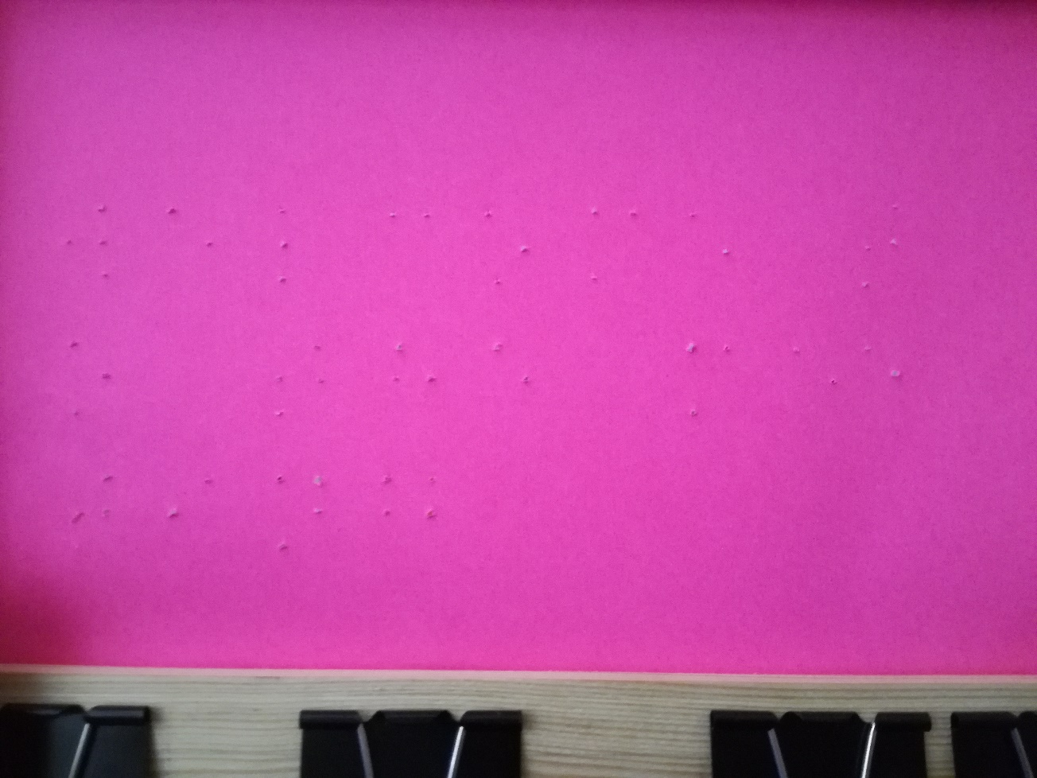

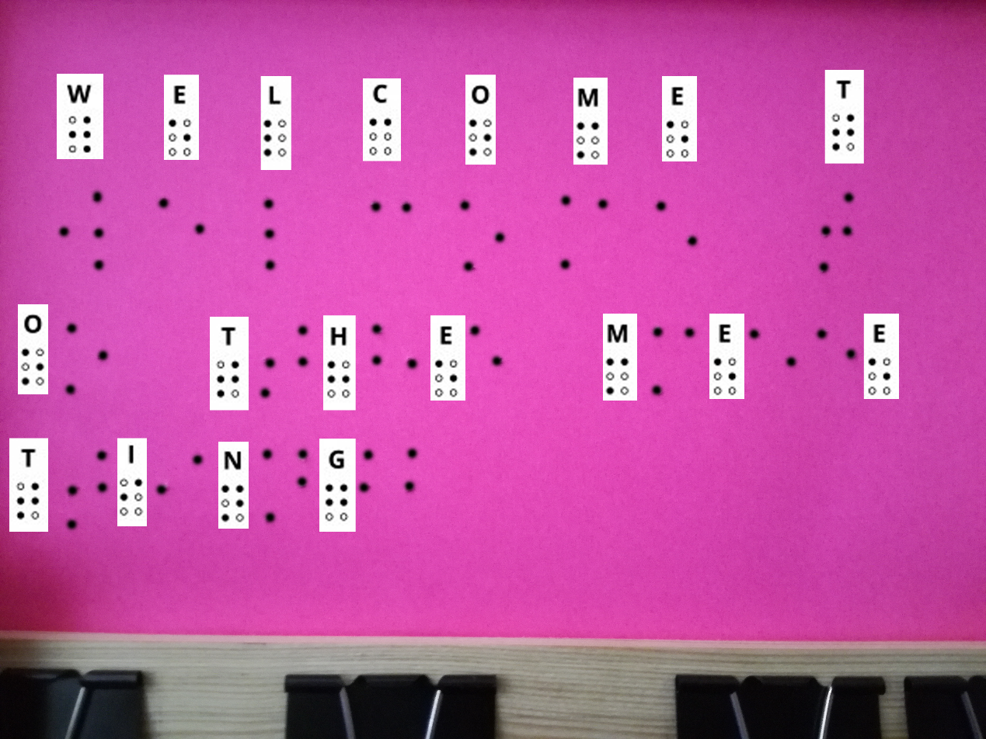

Sentence tested: “welcome to the meeting”

The next test is to cover the treatement of numbers and capitals by our machine (number indicator and the capitalization indicator).

HOW MUCH OF OUR GOAL HAVE WE ACHIEVED?

Our initial goal was a simple pdf to braille printer, it allows visually impaired people to print pdfs on the spot without any vision supervision from another human which we have achieved fully, a visually impaired person is now able to do that thanks to our machine, we wish our machine to be able to print full books without replacing paper manually, we are glad we were able to build this machine regardless of the lack of 3D printed pieces that the school club couldn’t provide before the corona outbreak, we strived to build a compelling prototype ourselves with wood and it worked, we can safely say we have achieved 90% of what we initially aimed for.

Engineers are people who can solve a provided problem with the resources they have, we were able to build an accurate pointing machine with wood and ourselves only which at first we thought was going to be impossible to achieve, we relied on 3D printed pieces that were supposed to be provided from the school club but we weren’t able to obtain those before the outbreak.

Initially we thought this was going to be an attainable task but by the end of it we realised it costed us 2000 lines of code and many many hours of hardward building.

Also, Initially we thought we can use a simple tiny servo motor for the poking head but we were extremely wrong and had to change our path to using a third nema 16 stepper motor which was strong enough with its own timing belt and our exclusive design.

Wood is a difficult tool to work with in such precise applications, especially when we have to build it ourselves due to lack of the ability to travel during the confinement aswell as the difficulty to explain to a carpenter how specifically we want our machine to be built, we had to make it ourselves which miraculously has not affected the accuracy of our machine a single bit, we would like to think it was due to our dedicated and precise work cutting and sawing the wood in the most accurate way possible.

CONCLUSION:

We conclude that printing braille is vastly different from regular text printing, it wasn’t easy to make a mechanism that could force a syringe on a paper to poke it without actually tearing it appart while still having it be readable and clean looking.

Louise Braille’s invention has impressed us a lot during this project as we have learned that he gave both letters and numbers the same braille letter to save visually impaired people from having to learn many more characters, a simple number indicator allows the reader to determine whether they’re reading letters or numbers.

Nema 16 stepper motors are very strong motors, we were scepticle about their performance as the poking head needs a lot of strength to poke paper accuractely, these motors have surprised us with their performance and accuracy in stepping in each direction.

APPENDIX 1:

Source 1: <https://www.amazon.com/MaxiAids-Braille-Slate-Plastic/dp/B00I5PNG4Y>

Source 2 : <https://journals.openedition.org/traduire/386>

Source 3 : <https://fr.wikipedia.org/wiki/Louis_Braille>

Source 4 : <https://www.pathstoliteracy.org/blog/teaching-braille-writing>

Source 5 : <https://www.premiere.fr/Cinema/News-Cinema/Un-nouveau-realisateur-pour-la-suite-de-Don-t-Breathe>

Source 6 : <https://french.alibaba.com/product-detail/nema-16-stepper-motor-size-39mm-stepper-motor-catalogue-60557322173.html>

Source 7 : <https://www.amazon.fr/AZDelivery-Digitales-Micro-Servo-Parent/dp/B081Z5V3M2>

Source 8 : <https://fr.aliexpress.com/item/32332956978.html?spm=a2g0o.productlist.0.0.56bb3477vI7vGX&algo_pvid=591ad536-3ff4-45a6-a624-23216434f726&algo_expid=591ad536-3ff4-45a6-a624-23216434f726-1&btsid=0ab6f81615941407278862326e0bb6&ws_ab_test=searchweb0_0,searchweb201602_,searchweb201603_>

Source 9 : <https://www.amazon.com/Aluminum-Pulley-2Meters-Timing-Belt/dp/B01AN3ZK9E>

Source 10 : <https://www.instructables.com/id/Build-Your-Own-Drawing-Machine/>

Source 11 : <https://www.instructables.com/id/SIMPLEST-Arduino-Vertical-Plotter/>

Source 12 : <https://www.thesun.co.uk/news/5541046/braille-alphabet-how-read-louis-braille-writing-system/>

GENERALITIES & DEFINITIONS:

G-code: a term wellknown in the 3D printing industry which is used to refer to any method used to convert digital content into machine coordinates which are then used to print something in 2D or 3D, this method is machine-specific and must be tailored for each size and purpose of machine, g-code is generally code programmed in a programming language chosen by the programmer himself and isn’t language specific.

CAD: a wellknow term in 3D printing and is used to refer to any program that is used to design objects in 3D, CAD itself is a 3D design program too.

Stepper Motor: a DC motor that is widely used for printing purpose due to its accuracy, it works by spinning at exact amounts of degrees every time and the fact that it spins the exact same angle every time makes it the perfect component to print something accurately.

Servo Motor: it is similar to a Stepper Motor but this one uses a potentiometer to spins to exact angles specified by code, it isn’t as accurate as a Stepper Motor but is cheaper.

Linear Shafts: an iron rod used as axis for the motor to keep its motion absolutely accurate, it is vastly used in 3D printers.

Timing Belt: a belt with teeth on it, it helps a motor convert its spinning motion into an axis motion, this axis relies on Linear Shaft to say in its path.

IDE: and program that lets you code any other program within, IDE stands for Integrated Development Environment (examples: Processing 3, Pycharm, Atom.io, CodeBlocks, Dev++).

Processing 3: a programming IDE used to make games and is used a lot in machinery.

Poking Head/Threading Head: the mechanism that directly threads the paper to print braille, it is also used to draw 2D objects and is used by 3D printers to apply the hot plastic that forms the objects.

Numeric Indicator: a symbol in the braille language that is added before every string of numbers to indicate that what’s coming next are numbers, it is necessary as numbers and letters in braille have the same letters.